The Sebadenitis Study
Dear Akita friends!
To evaluate our very promising results in SA-research we need your help!
Please send us BLOOD-samples from SA- affected Akita.
Biopsies are NO LONGER needed!
Only 2ml EDTA-Blood is necessary!
With your engagement you can maybe spare suffering for a lot of dogs.
You can send the blood by post.
You only have to ensure, that the blood reaches Kassel in max.5 days!
Please send samples to:
PD Dr. Ina Pfeiffer
Institut für Biologie
Universität Kassel
Heinrich-Plett-Strasse 40
D-34109 KASSEL
Prior consultation:
Telefon: 0049-(0)561 804 4775
Sekretariat: 0049-(0)561 804 4787

SA Donation - New bank information
Bank information for foreign remittandes:
To: Universität Kassel - " SA-Spenden: 51821002 Dr. Pfeiffer" (bitte für die Zuordnung angeben)
Landesbank Hessen-Thüringen
Account number: 1006436
Bank code: 50050000
BIC (Swift-Code): HELADEFF
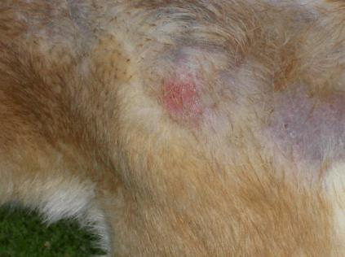 | 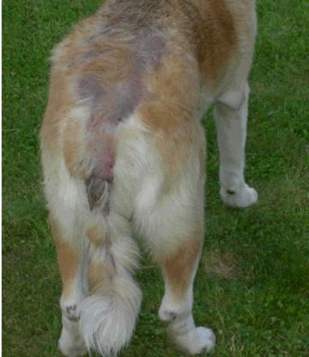  Please help to anticipate this suffering!  Only 2 ml. blood of your SA-affected Akita is needed!
